­

* ProFile

Find and Delete Unused Measures and Speed Up the Dynatrace Server!

Collin Lesko, Arnaud Crowther





**Contents**

1

1. Introduction 3

1.1 Installation 3

2. Tutorial 3

2.1 Additional Options 5

1. Introduction

ProFile has been developed to help eliminate “measure explosion”, and to assist in the performance of the Dynatrace Server. The program will scan and process all dashboards, alerts, incidents, etc.. and tell you how many times a measure is being used (0 - # of occurrences). You are then able to sort the data, save it off, and delete the measures with zero uses.

1.1 Installation

Unzip the file and run the JAR.

2. Tutorial

1. Export your system profile xml and save off 2 copies (One as a backup).
   1. 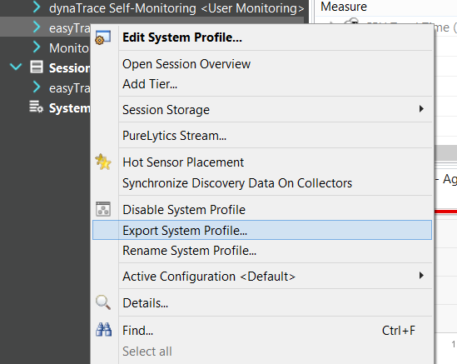
2. Zip all your dashboards (excluding the web folder). They are located under **“<DYNATRACE HOME>/server/conf/dashboards”**.
   1. 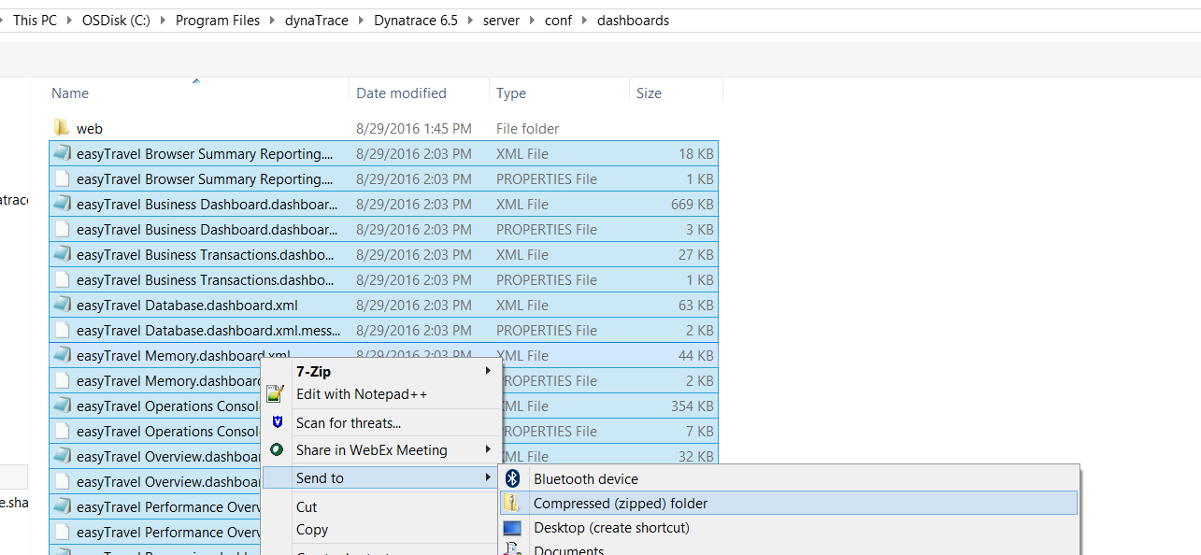
3. Move the zip to your desktop so it is easy to find along with a copy of your system profile.
   1. 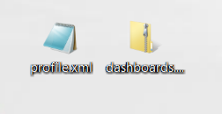
4. Open the JAR file and import both files
   1. 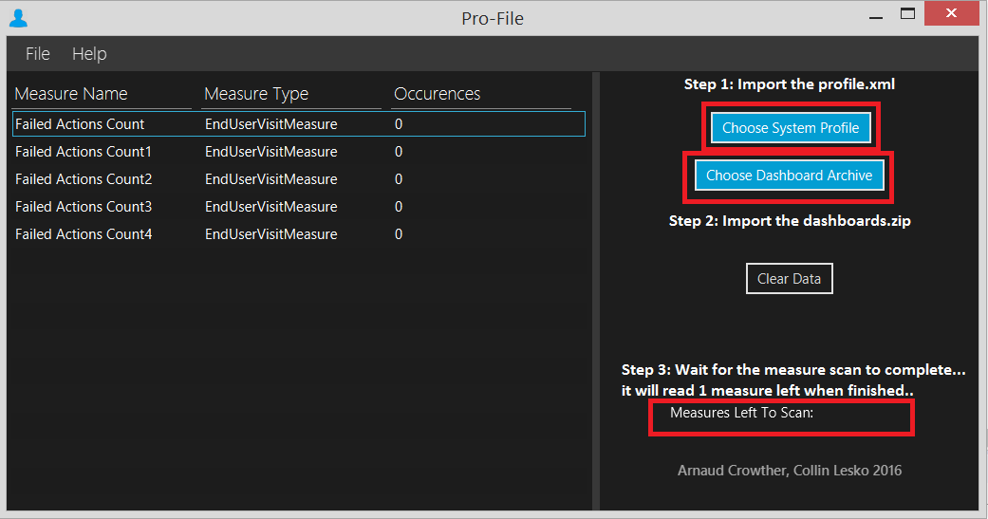
5. Your measures will begin to increase in count and you can eliminate those with 0 “Occurrences”.
   1. 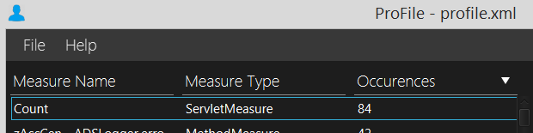
   2. 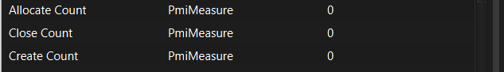

2.1 Additional Options

1. You can also save off the list of measures with all the data displayed by going to File -> Save.
   1. 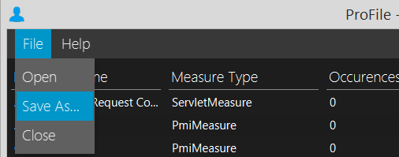
2. The “Clear Data” button will wipe all data for you to start fresh.
   1. 